Software Design Specification

NutriDiet (E- Nutritionist & Dietitian)


Project Code:
BS-112010

Internal Advisor:
Mr. Ramzan Malik

External Advisor:
Dr. Zonaira Masood

Project Manager:
Dr. Muhammad Illyas

Project Team:
Sr. No | Name | Roll No | Role
1. | Fatima Masood | BSEF19M020 | Team Lead
2. | Esha Tahir | BSEF19M011 | Team Member

Submission Date:
15-12-2022

_________________
Project Manager’s Signature

Document Information

Category | Information
Customer | CS & IT, UOS
Project | NutriDiet (E- Nutritionist & Dietitian)
Document | Software Design Specification
Document Version | 1.0
Identifier | BS-112010
Status | final
Author(s) | Fatima Masood, Esha Tahir
Approver(s) | PM
Issue Date | Dec. 22, 2022
Document Location
Distribution | - Advisor  - PM  - Project Office

Definition of Terms, Acronyms, and Abbreviations

Term | Description
UML | Unified Modeling Language
BMI | Body Mass Index
ER | Entity Relationship
FS | Functional Specifications

Table of Contents

1. Introduction 4
1.1 Purpose of Document 4
1.2 Project Overview 4
1.3 Scope 4
2. Design Considerations 4
3. System Architecture 5
3.1 System Level Architecture 5
3.2 Sub-System / Component Level Architecture 6
4. Design Strategies 6
4.1 Future system extension or enhancement..........................................................................6
4.1 System reuse......................................................................................................................6
5. Detailed System Design 7
6. References 9

Introduction
The design document of NutriDiet is as follows:

  - Purpose of Document
The main purpose of this document is to show the design description of the project with the help of some UML diagrams. The project developer needs this document to understand the flow of the application and after that to write code. This document will show the flow of objects, and entities for a developer.

  - Project Overview
Nutrition is important for living a healthy life. Most people neglect their diet due to which they face many day-to-day health problems. To solve nutrition and diet-based issues, we have decided to build software that will suggest a customized diet plan and water intake levels with reminders according to BMI for a normal routine diet. NutriDiet is an online web application with machine learning about human nutritional needs and diets. The user registers them on the app by providing essential details like name, email, and phone number. After registering, the user will fill out a questionnaire regarding weight, age, gender, height, and medical history. The user will get a customized diet plan based on personal and medical details.

  - Scope
Different plans are generated for different BMI results (fit, overweight, underweight), and periods of pregnancy (first trimester, second trimester, and third trimester). It will also generate customized diet plans for diabetic, arthritic, and heart patients.

Design Considerations
Developing new products is risky, especially the more innovative they are. Following are some risks and considerations for getting ready to dive into new web application design projects and how it can help to avoid problems along the way:
Technical risks: The product is too complex and technically not feasible as planned. The technology fails after a certain period of use. No professional knowledge or experience. When incorporating new technology into a product, there is a chance that the team may have blind spots or lack specific capabilities that could cause roadblocks during development.
Where NPI comes in: Bringing in outside experts, such as an advanced manufacturing partner, can fill in knowledge gaps and add capabilities to your project team.
Performance risks: The function and reliability of the product in real-world conditions are always unknown until it is built and can be tested. However, any performance issue late in the game can be a major setback. Where NPI comes in: During the Develop and Validate steps, functional prototyping and testing are conducted to confirm the product works as intended.
Financial risks: The cost of a project is very important for both clients and developers, as it will estimate the project’s total budget. The clients ask for the expected cost of the project from the developers, it depends on the complexity of the web app and skilled developers. However, if the requirements of the project change over time, it may affect the cost of a project and companies turn out or even leave the project. Restricted access to capital or arising issues that put the project over budget can prevent a new product from crossing the development finish line. Where NPI comes in: The right plan can lower overall development costs, accelerate speed to market, and enhance manufacturability – all things that can benefit the bottom line.
Health Risks: The new product could endanger health in some way, for example, the diet plan may provide some sort of danger to the health of a user if a user has not provided the required information correctly. Therefore, before developing a product it is compulsory to have a detailed discussion with a medical specialist regarding the project so that no severe mistakes or problems occur.

System Architecture
This section provides a high-level overview of how the functionality and responsibilities of the system are partitioned and then assigned to subsystems or components.
  - System-Level Architecture
Following are UML diagrams to document the overall system architecture:

    - CONTEXT DIAGRAM

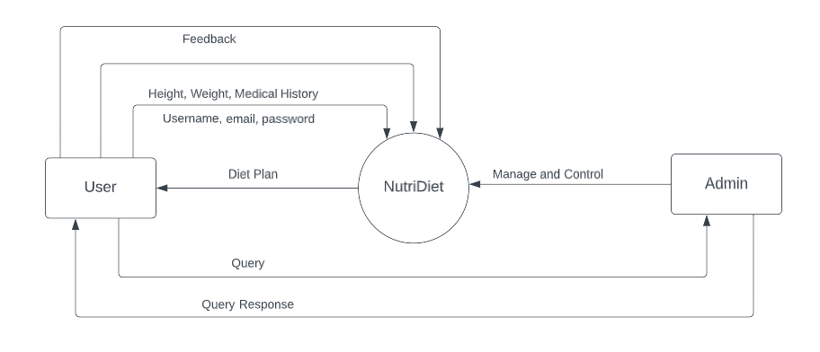
Figure 3.1 Context Diagram for System Architecture.

  - Sub-System / Component Level Architecture

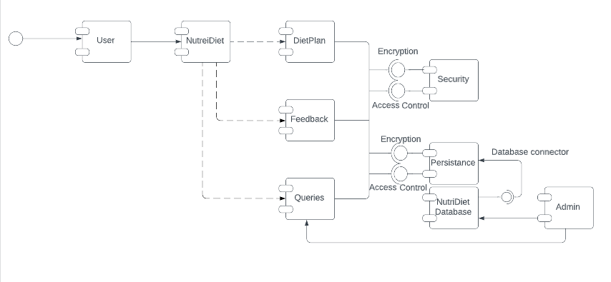
Figure 3.2 Component Diagram for System Architecture.

Design Strategies
Different design strategies or decisions influence the overall organization of the system and its high-level structures. This information provides insights into the key abstractions and mechanisms used in the system architecture.
  - Future system extension or enhancement
NutriDiet is a software with some limited functionality as mentioned above in this document. Regarding its extension or enhancement, we can add testing procedures before generating the diet plan for the required patients. It will require more knowledge and innovative technology as we plan to replace physical nutritionists with e-nutritionist. We can also increase our scope by adding categories.
  - System reuse
The system that is generating diet plans can be reused in other websites that can generate different types of plans like this one. It can also be used in medical websites, which want to generate medical prescription

Detailed System Design
A detailed design of NutriDiet the following:

  - Use case Diagram:

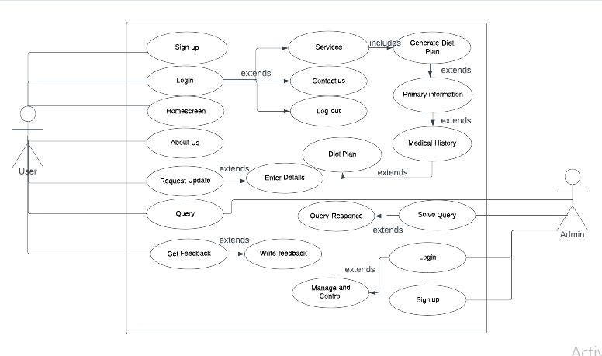
Figure 5.1 Use case Diagram for NutriDiet

5.2 ER Model:

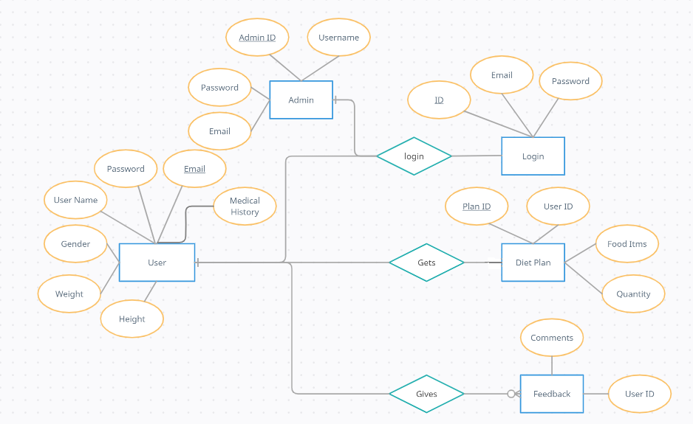
Figure 5.2 ER model
5.3 Class Diagram:

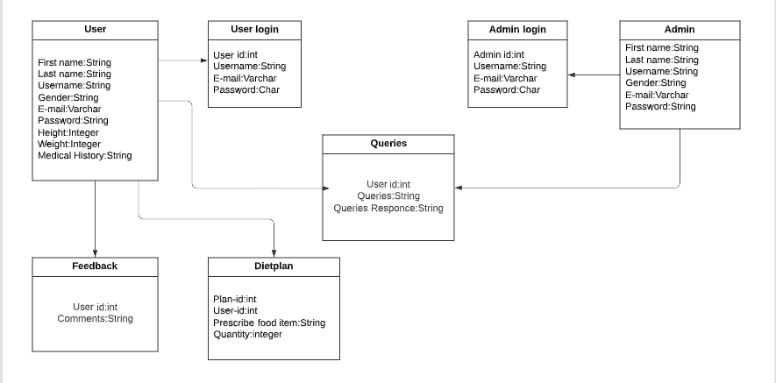
Figure 5.3 Class Diagram for NutriDiet

5.4 State Transition/Activity Diagram:

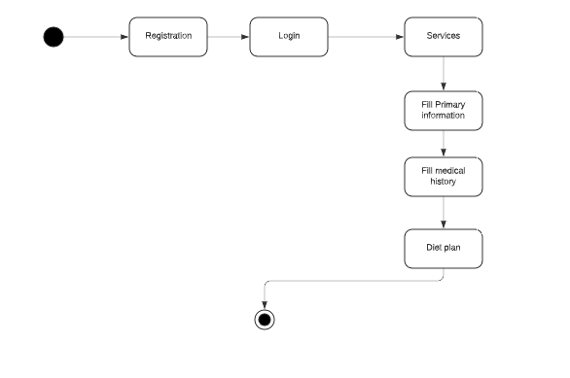
Figure 5.4 State transition/ Activity Diagram for NutriDiet
5.5 Sequence Diagram:

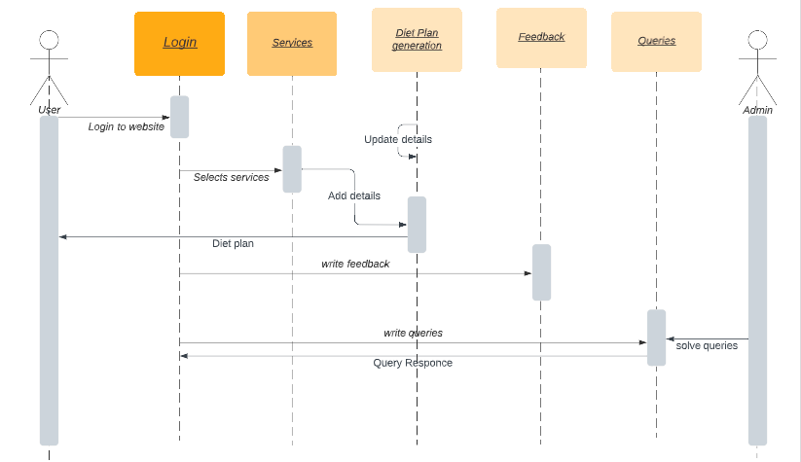
Figure 5.5 Sequence Diagram for NutriDiet

References

Ref. No. | Document Title | Date of Release/ Publication
BS112010-2022-Proposal | Project Proposal | Oct 11, 2022
BS112010-2022-FS | Functional Specification | Nov 15, 2022

